­­­­

**BRING SCHOOL LIBRARIES BACK!**

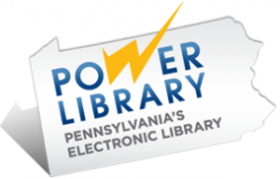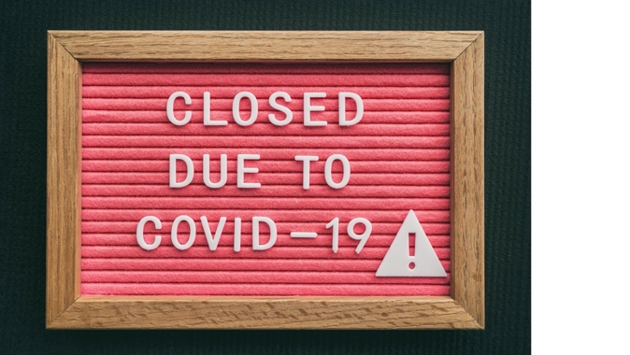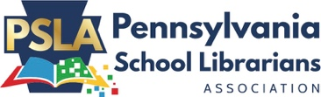

Facilitated by the Pennsylvania School Librarians Association

**Student or Parent Quote Here**

School Librarians teach students how to access and use the PA State funded POWER Library eResources worth almost $60,000.

**value of our school library collection**

**$xXX,XXX**

**RESEARCH FACT**

Certified school librarians correlate to higher reading and writing test scores. In fact, greater improvements are realized in Black, Hispanic students and students with disabilities.

-[Source: PA Study](https://paschoollibraryproject.org/home/research)

**X School District**

X% Economically Disadvantaged X% English Learners

X% Under Represented X% Special Services

X% Proficient & Advanced PSSA X% Graduation Rate

**# of PA STandards**

**Skills Taught**

**Grades PK - 2 = 64**

**Grades 3 - 5 = 48**

**Grades 6 - 8 = 42**

**Grades 9 - 12 = 42**

[*Model Curriculum for PA School Library Programs*](https://www.psla.org/model-curriculum-for-pa-school-library-programs)

[www.psla.org](http://www.psla.org/)

**Pre-PANDEMIC**

**School LibrarieS**

***Kids Can't Wait to get Back in their School Libraries***

**Pre-PANDEMIC**

**School LibrarieS**

Add info, stats and images

of Books and eBooks

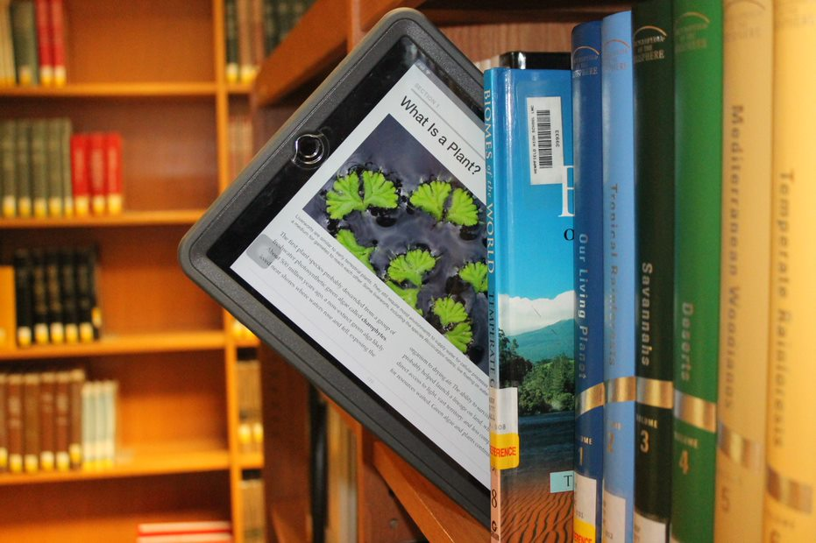

**RESEARCH FACT**

"Reading what you want is responsible for most of our literacy development. Free voluntary reading improves reading ability, writing, spelling, vocabulary and grammar."

-[Stephen Krashen](http://www.sdkrashen.com/)